**Audit Course Report**

On

**Leadership and Personality Development**

By

Giramkar Shrushti Ankush

Roll No: 19

Under the guidance

of

**Prof. Bhosale S. S.**

Year of Submission: 2023-2024



HSBPVT’S

PARIKRAMA FACULTY OF ENGINEERING, KASHTI

DEPARMENT OF COMPUTER ENGINEERING

**HSBPVT’s GOI Faculty of Engineering, Kashti**

DEPARTMENT OF COMPUTER ENGINEERING

KASHTI



This is to certify that **Miss. Giramkar Shrushti Ankush** from **Third Year Computer Engineering** has successfully completed her Audit Course work titled **“Leadership and personality Development”** at HSBPVT’S of Engineering, Kashti in the partialfulfilment of the Bachelor’s Degree in Engineering of Savitribai Phule Pune University.

Prof. Bhosale S.S

**Guide Name**

**ABSTRACT**

This abstract delves into the symbiotic relationship between leadership and personality development, elucidating how the interplay between these two constructs shapes individuals and organizations. Leadership, as a dynamic and multifaceted concept, requires a nuanced understanding of individual differences in personality traits, behaviors, and characteristics. Similarly, personality development encompasses the intricate process through which individuals evolve their traits, attitudes, and behaviors over time. This paper synthesizes contemporary research and theoretical frameworks to expound upon how leadership practices contribute to personal growth and vice versa.

It examines how various leadership styles interact with different personality traits, elucidating the impact on organizational dynamics, team effectiveness, and individual outcomes. Furthermore, it explores the role of self-awareness, emotional intelligence, and adaptability in fostering effective leadership and facilitating personal development. Through an integrative approach, this abstract aims to provide insights into the reciprocal relationship between leadership and personality development, offering implications for practice and future research in leadership studies and organizational psychology.

In the contemporary landscape of organizational dynamics, the symbiotic relationship between leadership and personality development emerges as a crucial determinant of individual and collective success. This abstract embarks on an exploration of the intricate connections between these two constructs, drawing upon a synthesis of empirical evidence and theoretical perspectives. Grounded in contemporary research, it elucidates how leadership practices serve as catalysts for personal growth, influencing the development of key personality traits and behaviors.

Conversely, individual personality traits shape leadership styles and effectiveness, thereby impacting organizational culture and performance. Through an integrative lens, this abstract delves into the role of self-awareness, emotional intelligence, and resilience in facilitating both effective leadership and personal development. Through an integrative approach, this abstract aims to provide insights into the reciprocal relationship between leadership and personality development, offering implications for practice and future research in leadership studies and organizational psychology.

**TABLE OF CONTENTS**

|  |  |
| --- | --- |
| **Sr. No** | **Title** |
| 1 | Introduction |
| 2 | Dimension of Personality |
| 3 | Personality Development |
| 4 | Teamwork Skills |
| 5 | New age Thinking |
| 6 | Self-Awareness |
| **7** | Self-Presentation |
| 8 | Relationship between Prejudice, Discrimination and Exclusion |
| 9 | Self-Esteem |
| 10 | Conclusion |
| 11 | References |

**INTRODUCTION**



In the dynamic landscape of organizations and communities, the intertwined dynamics of leadership and personality development stand as pillars shaping individual growth, team effectiveness, and organizational success. Leadership, a multifaceted concept rooted in influence and vision, intersects intimately with the process of personality development, which encompasses the evolution of traits, behaviors, and attitudes over time. This introduction lays the foundation for a comprehensive exploration of the intricate relationship between leadership and personality development, shedding light on their interplay, significance, and implications in contemporary contexts.

Leadership, as a concept, transcends traditional hierarchical roles, encompassing a spectrum of styles, approaches, and competencies. From visionary leaders who inspire change to collaborative facilitators who empower teams, the essence of leadership lies in the ability to mobilize resources, foster collaboration, and drive collective action towards shared goals. At its core, effective leadership hinges on self-awareness, empathy, and adaptability, enabling leaders to navigate complexities, inspire trust, and foster innovation in ever-evolving environments. Concurrently, personality development emerges as a lifelong journey of self-discovery and growth, influenced by a myriad of factors including genetics, upbringing, and life experiences. While personality traits may exhibit stability over time, individuals possess the capacity for self-directed change and adaptation, shaping their behaviors and interactions in response to internal and external stimuli. From introversion to extraversion, conscientiousness to openness, personality traits play a pivotal role in shaping leadership styles, communication patterns, and decision-making processes.

**THE FIVE DIMENSIONS OF PERSONALITY:**

1. **Openness to experience:**

Openness to experience describes a person's degree of intellectual curiosity, creativity, appreciation for art, emotion, adventure, unusual ideas, curiosity, and variety of experience. It is also described as the extent to which a person is imaginative or independent, and depicts a personal preference for a variety of activities over a strict routine. High openness can be perceived as unpredictability or lack of focus. Moreover, individuals with high openness are said to pursue self-actualization specifically by seeking out intense, euphoric experiences, such as skydiving, living abroad, gambling, etc. Conversely, those with low openness seek to gain fulfilment through perseverance, and are characterized as pragmatic and data driven, sometimes even perceived to be dogmatic and closed-minded. Some disagreement remains about how to interpret and contextualize the openness factor.

1. **Conscientiousness:**

Conscientiousness is a tendency to show self-discipline, act dutifully, and aim for achievement. Conscientiousness also refers to planning, organization, and dependability. High conscientiousness is often perceived as stubbornness and obsession. Low conscientiousness is associated with flexibility and spontaneity, but can also appear as sloppiness and lack of reliability.

1. **Extraversion:**

Extraversion describes energy, positive emotions, assertiveness, sociability, talkativeness, and the tendency to seek stimulation in the company of others. High extraversion is often perceived as attention seeking, and domineering. Low extraversion causes a reserved, reflective personality, which can be perceived as aloof or self-absorbed.

1. **Agreeableness:**

Agreeableness is a tendency to be compassionate and cooperative rather than suspicious and antagonistic towards others. It is also a measure of one's trusting and helpful nature, and whether a person is generally well-tempered or not. High agreeableness is often seen as naive or submissive. Low agreeableness personalities are often competitive or challenging people, which can be seen as argumentative or untrustworthy. e. Neuroticism: Neuroticism is a tendency to experience unpleasant emotions easily, such as anger, anxiety, depression, and vulnerability. Neuroticism also refers to the degree of emotional stability and impulse control and is sometimes referred to by its low pole, "emotional stability".

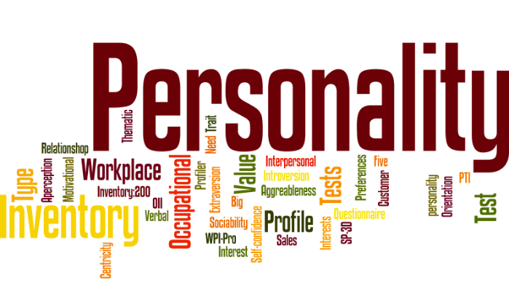

**PERSONALITY DEVELOPMENT:**

* Personality development includes activities that improve awareness and identity, develop talents and potential, build human capital and facilitate employability, enhance quality of life and contribute to the realization of dreams and aspirations.
* When personal development takes place in the context of institutions, it refers to the methods, programs, tools, techniques, and assessment systems that support human development at the individual level in organizations.
* Personality development includes activities that develop talents, improve awareness, enhances potential and looks to improve the quality of life. It involves formal and informal activities that put people in the role of leaders, guides, teachers, and managers for helping them realize their full potential.
* Hence, it can be concluded that the process of improving or transforming the personality is called personality development.

**Nature and Characteristics:**

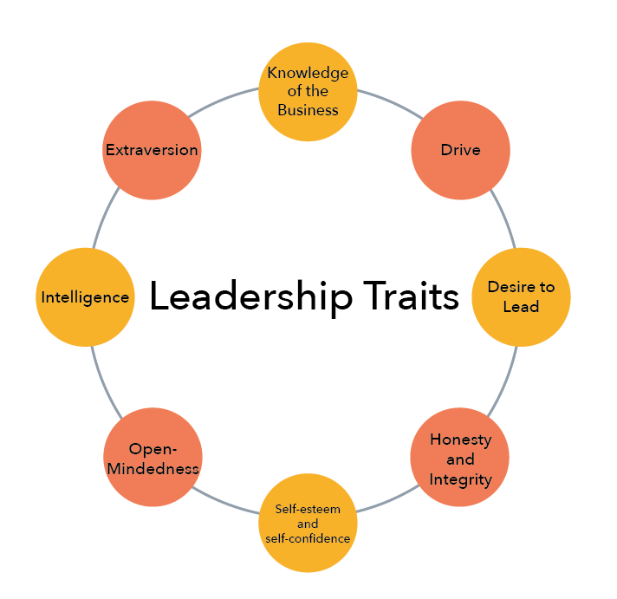

* Leadership is a personal quality.
* It exists only with followers. If there are no followers, there is no leadership.
* It is the willingness of people to follow that makes person a leader.
* Leadership is a process of influence. A leader must be able to influence the behaviour, attitude and beliefs of his subordinates.
* It exists only for the realization of common goals.
* It involves readiness to accept complete responsibility in all situations.
* Leadership is the function of stimulating the followers to strive willingly to

**Some key points for Leadership and Personality Development:**

1. **The Power of Teamwork**:

Collaboration is the cornerstone of success in **India's social sector**. Unlike the corporate world, where solo endeavours are common, here, teamwork is non-negotiable. In a sector where diverse stakeholders come together, the ability to collaborate, communicate, actively listen, and understand various viewpoints is essential. It's teamwork, but with a social twist.

* ***Effective Communication:*** In the social sector, being able to communicate clearly is pivotal. Effective communication ensures that your message is understood, reducing the risk of project roadblocks.
* ***Empathetic Engagement:*** Empathy is key in understanding the perspectives of the people you serve. It allows you to connect on a deeper level, which is often vital for effective social impact.

**2. Critical Thinking: Unravelling Complex Challenges**

In the complex web of India's social sector, critical thinking is your compass. Many of the issues tackled in this field are interconnected and interdependent. To succeed, you must think critically, examining problems from multiple perspectives and using data, evidence, and accounts to arrive at holistic solutions. Critical thinking allows you to view situations neutrally and make well-informed decisions, an invaluable skill for NGOs and the development sector.

* **Problem-Solving Prowess**: Critical thinking enables you to identify problems and develop creative solutions, a skill that is indispensable in tackling complex social issues.
* **Data-Driven Decision-Making**: Making decisions based on reliable data ensures that your efforts are focused on strategies that are more likely to succeed.

**3. Networking: Building Bridges for Change**

Networking isn't just a buzzword; it's a superpower in the social sector. It opens doors to knowledge exchange, collaboration, and new opportunities. In India's vast and diverse landscape, professionals often work on similar issues in different regions. Networking bridges these geographical gaps, enabling the sharing of ideas and mutually beneficial conclusions.

* **Knowledge Sharing**: Networking allows you to tap into the collective wisdom of your peers, helping you discover innovative approaches and best practices.
* **Partnerships and Alliances**: Building a network of partners can expand your resources and enhance your capacity to drive meaningful change.

**4. Thriving Under Pressure**

The social sector in India often deals with sensitive issues and an overwhelming workload. But with the right approach, you can thrive under pressure. Social Purpose Organizations (SPOs) often provide a supportive community that helps mitigate the stress associated with job demands. Additionally, you can employ various stress management techniques to ensure you remain effective and resilient, no matter how challenging the circumstances may be.

* **Stress-Reduction Strategies**: Learning to manage stress through techniques like mindfulness and time management can significantly improve your performance.
* **Supportive Work Environment**: Being part of an organization that values work-life balance and offers support can be a game-changer for professionals in the social sector.

**5. Willingness to Learn and Unlearn**

The ability to learn and unlearn is the secret sauce of success in India's social sector. Learning new skills and concepts empowers you to adapt to evolving circumstances and excel in your role. But equally important is unlearning the process of letting go of outdated or incorrect ideas. In this dynamic field, you may encounter concepts that challenge your existing beliefs. Embracing unlearning and relearning is crucial for staying adaptable and effective.

* **Continuous Professional Development**: A commitment to ongoing learning ensures that you remain relevant in a field that constantly evolves.
* **Adapting to Change**: Embracing new ideas and approaches can lead to ground-breaking innovations and solutions.

**6. Cultivating Empathy**

Empathy is a soft skill that can't be overlooked in the social sector. Understanding and sharing the feelings of those you serve is at the heart of creating meaningful change. Empathy allows you to connect with the people you aim to assist on a deeper level and truly make a difference.

* **Client-Cantered Approaches**: An empathetic approach helps you tailor your services to the unique needs and experiences of your clients.
* **Building Trust**: Demonstrating empathy fosters trust, which is essential in a sector where trust can be the difference between success and failure.
* **Teamwork Skill:**



Teamwork skills are the mix of skills that an employee uses to contribute to the group, and skills used to make the most out of everyone’s contributions. For organizations seeking to optimize how their teams interact, coaching is an effective approach for developing the skills that contribute to good team productivity.

**What Are Teamwork Skills?**

Strong teamwork skills enable employees to perform well within a group. These skills can be divided into two types:

1. Personal skills, which are internally focused and allow the employee to take on an effective role within the team.
2. Affiliative skills, which are outwardly focused and promote cooperation

In general, **Soft skills** are dominant, although **Hard skills** can come into play, such as working with scheduling programs and creating reports.

**Types and Examples of Teamwork Skills:**

Teamwork skills involve everything from communication to self-awareness. Being a team player isn’t just one distinct quality: It’s a collection of many soft skills that may come naturally to you or that you can improve on to make yourself a more competitive applicant and competent employee. Teamwork skills examples include:

1. **Communication.**



Good [**Communication Skills**](https://www.zippia.com/advice/communication-skills/) are arguably some of the most valuable skills team members can have. Businesses need effective communicators on their staff for projects to run smoothly and for clients’ needs to be met properly. Communication is more than simply being confident in your conversational skills. It’s the summation of many good communication habits.

Effective team communication relies on:

* Active listening skills
* Being friendly
* Respect
* Email Communication
* Paying attention to body language
* Understanding your audience
* Accurately express your ideas

1. **Conflict Management:**

Facing conflict happens at some point at every level in the workforce. How you deal with conflict speaks volumes about your skills as an employee in any field and can greatly improve your career growth.

A candidate with strong [conflict management skills](https://www.zippia.com/advice/conflict-resolution-skills/) looks at disagreement on your team as an opportunity for further clarification and collaboration.

Constructive conflict management techniques include:

* Always being open to discussion.
* Remaining unbiased.
* Addressing issues immediately.
* Actively listening before a response.
* Optimism.
* Effective negotiation.
* Solution-based strategic thinking.

1. **Active Listening:**

Many of the abilities needed to be a great team player are based on listening skills. The concept of listening isn’t nearly as exciting for most people as speaking and expressing their own views, but it’s vital to a functional team.



However, active listening involves more than just sitting back and collecting the general idea of your team’s input. It’s a process of connection where both the [speaker](https://www.zippia.com/speaker-jobs/jobs/) and the listener can leave the interaction feeling satisfied with their understanding .[Active listening skills](https://www.zippia.com/advice/active-listening/) include:

* Giving your undivided attention to the speaker
* Paying attention to nonverbal cues
* Making eye contact
* Repeating points for clarification
* Asking questions.

1. **Reliability:**

Your team needs to know wholeheartedly that they can rely on you. Being a reliable part of a team means accomplishing the job requirements and finishing assignments before their deadline.

If employers find your [reliability skills](https://www.zippia.com/advice/reliability-skills/) questionable, they may doubt your ability to be an effective team member. This can result in landing fewer positions or not being trusted to handle [leadership roles](https://www.zippia.com/team-leader-jobs/). Being reliable usually involves:



* Being on time
* Staying organized
* Taking notes
* Meeting deadlines
* [Double-checking](https://www.zippia.com/double-jobs/jobs/) your work
* Asking questions if you don’t understand something.

1. **Accountability:**

Holding yourself accountable for your work is a desirable teamwork skill. It allows your co-workers to trust you. Nobody wants to deal with team members who shift blame for faults or can’t acknowledge their mistakes.

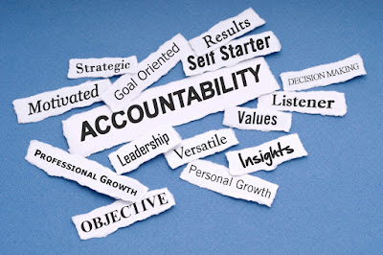

[Accountability is important](https://www.zippia.com/advice/what-is-accountability/) for employers building a team because if you hold yourself accountable, you won’t want to present anything other than your best work.Here are some examples of accountability skills in the workplace:

* Immediately owning, apologizing for, and addressing mistakes
* Being honest about your abilities
* Meeting deadlines
* Setting and reaching goals
* Graciously receiving feedback
* **New Age Thinking:**

New-age leadership is a style of leadership that emphasizes the use of creativity, innovation, and adaptability to solve problems and achieve goals. It is a response to the rapidly changing business landscape, where traditional leadership styles may no longer be effective. In this article, we will explore some of the key characteristics of new age leadership and how it is changing the way we think about leadership in the modern world.

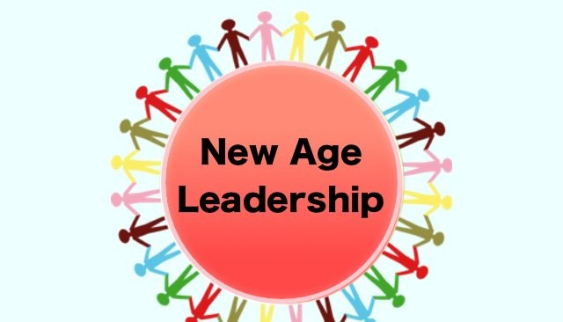

One key characteristic of new-age leadership is the ability to be flexible and adaptable. With the constant changes in technology and the global economy, leaders must be able to adapt to new situations and find creative solutions to problems. This means being open to new ideas, even if they challenge traditional ways of thinking, and being willing to take risks in order to achieve success. Another characteristic of new-age leadership is the focus on collaboration and teamwork. Gone are the days of the top-down, hierarchical leadership style. Today's leaders recognize the value of diverse perspectives and encourage collaboration and open communication throughout their organizations. This approach not only helps to foster a positive work culture but also leads to better decision-making and more innovative solutions to problems.

In addition to being flexible and collaborative, new-age leaders are also often described as visionary and forward-thinking. They have a clear vision for the future of their organization and are able to inspire and motivate their team to work towards that vision. They also understand the importance of staying current and are always looking for ways to innovate and stay ahead of the competition. New-age leaders also place a strong emphasis on personal and professional development. They recognize that their team members are their most valuable asset and invest in their growth and development. This may include providing opportunities for training and professional development, as well as creating a positive work culture that supports work-life balance and personal well-being.

* **Transition from Convectional to Modern Leadership:**

Organisations in the past were built around an industrial mindset that prioritised stability, scalability, and predictable outcomes. Their main goal was to maximise profits for stakeholders with lesser focus on the holistic development of the workforce and empowering them for the ever-evolving business landscape. However, time has changed.  With the emergence of a tech-savvy era, the shift from manual to automated work, and the demand for more approachable work environment, organisations have realised that this traditional leadership style no longer suitable for the complexities of present day’s workplace. They understand that focusing solely on financial gains in short term is not enough. As a result, these forward-thinking organisations are embracing the power of holistic leadership – a collaborative, agile, and people-centric approach. This new model requires leaders to recognise the importance of collaboration between individuals, organisations, and their environments. By considering factors such as culture, values, attitudes, beliefs, and relationships, this modern approach goes beyond acquiring regular skills and expertise.

**A Few Essential that New Age leader should embrace:**

In today's fast-paced and constantly evolving workplace, modern and transformative leadership presents strategic advantages that enable leaders to promote growth, encourage open communication, and drive sustainable success. Yet, to unlock these incredible benefits, leaders must wholeheartedly embrace the following essentials.

1. **Holistic Model of Leadership:**

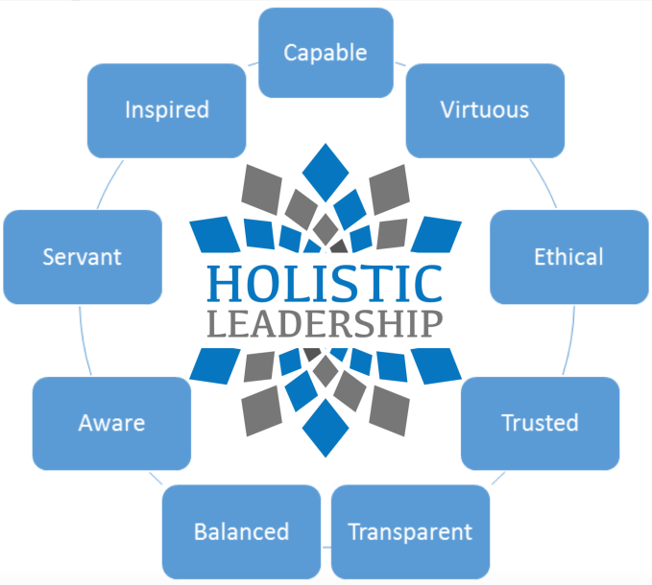

Managers who practice holistic model of leadership has the potential to empower employees by uniting them around shared goals and values. It creates a supportive work environment, resulting in numerous positive outcomes such as:

* Improved productivity and consistency in product quality
* Enhanced profitability due to coordination about team members
* Strengthened business relationships and reliability
* Higher job satisfaction and reduced turnover

It emphasises the importance of maintaining a balance between personal and professional growth, investing in oneself and others, and cultivating a collaborative, agile, and supportive organisational culture.

1. **Sense of ownership and greater involvement:**

In the past, team leadership primarily revolved around delegating work to different teams and monitoring progress. However, in this modern era, effective team leadership goes beyond delegation.



Modern leaders or managers have embraced a more hands-on approach, actively investing themselves in their teams and organisations. While they still delegate task, they also actively participate in performing additional responsibilities such as training and mentoring their team members. By doing so, they not only ensure the successful completion of tasks but also foster the professional and personal growth of their team members. To take ownership of your work and accomplish your career goals, you need to be honest with your manager about what you want to achieve in your job role, which areas you want to learn more about and the projects or job duties you enjoy most. Being honest with them is important because it helps them better understand your needs as an employee. It also helps you work with your manager to establish performance milestones and determine new tasks that align with your interests.

While they still delegate task, they also actively participate in performing additional responsibilities such as training and mentoring their team members. By doing so, they not only ensure the successful completion of tasks but also foster the professional and personal growth of their team members.

1. **Strategic Thinking:**

Strategic thinking in leadership is the ability to analyzed and understand the big picture of a team or project, anticipate potential challenges and opportunities, and make informed decisions that align with long-term goals. It involves considering the short and long-term implications of decisions, prioritizing tasks and projects, and quickly adapting to market or industry changes. Leaders who think strategically can effectively communicate their vision and goals to their team and make data-driven decisions that drive the team’s success.



It’s important to note that this skill involves both analytical and creative thinking. Leaders who think strategically must be able to gather and analyzed data, identify trends and patterns, and use that information to make informed decisions. However, they must also be able to think creatively, consider different perspectives and approaches to problems, and develop innovative solutions that move the team forward. Another critical aspect of strategic thinking in leadership is the ability to anticipate change and plan for the future.

This involves developing contingency plans to address potential challenges and taking advantage of emerging opportunities. It involves considering the short and long-term implications of decisions, prioritizing tasks and projects, and quickly adapting to market or industry changes. Leaders who think strategically can effectively communicate their vision and goals to their team and make data-driven decisions that drive the team’s success.

1. **Problem Solving:**

Being a good problem solver is one of the essential skills that a good leader needs to possess. Problem-solving requires tackling problems with a can-do attitude and objectivity, as well as [thinking strategically](https://womenatwork.ae/training-courses/master-strategic-thinking-problem-solving-skills/) and providing concrete plans and solutions. By being a good problem solver, your team members will see you as a reliable leader whom they can trust and get inspiration from.

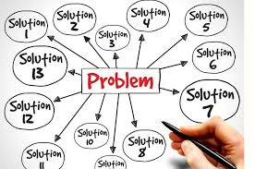

**Here are some Problem-Solving skills that can help with leadership:**

* **Communication:** The foundation of Problem-Solving, communication involves being able to express ideas clearly, collaborate with colleagues and provide honest feedback.
* **Time Management:** Problem-solving should be able to respond quickly and organize their time intelligently.
* **Adaptability:** Being able to quickly adapt to change and respond to unexpected circumstances shows resourcefulness, determination, leadership and Problem-Solving.

***Self-Awareness***

**What is self-awareness in leadership?**

Self-awareness is a common trait among exceptional leaders with various leadership styles: being better equipped to make informed decisions, taking responsibility for their actions, and inspiring trust and respect among their teams. By continuously seeking feedback and reflecting on their performance, these leaders can identify areas for improvement, proactively develop their skills, have corrective measures for their deficiencies, and skilfully navigate intricate interpersonal relationships with empathy and consideration.

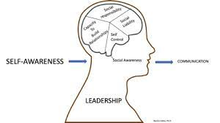

Self-awareness in leadership is an understanding of how your personality traits habits and abilities affect your interactions with the people around you, particularly in the workplace. Leaders who are self-aware actively reflect on how others perceive their words and actions and work to change their approaches so they can lead their peers more effectively. Self-awareness leads to personal control and growth that helps leaders use their strengths to guide teams to the best possible outcomes. Self-awareness plays a pivotal role in effective leadership, serving as a fundamental building block for both personal and professional development since it entails the capacity to impartially acknowledge and comprehend one’s own emotions, strengths, weaknesses, and values. Proactively develop their skills, have corrective measures for their deficiencies, and skilfully navigate intricate interpersonal relationships with empathy and consideration.

**Why is self-awareness in leadership is important?**

Attaining self-awareness is important in leadership for many reasons, including the following:

* **Assisting leaders in making better choices:**

Effective leaders use self-awareness to manage their own behaviour and relationships. Leaders can develop self-knowledge to better compensate for their natural tendencies and abilities as they make decisions in the workplace.

* **Impacting a company’s finances:**

Companies may rely on self-aware leaders to be successful. Companies with greater success can also improve their financial standings.

* **Helping leaders understand what they bring to their role:**

Understanding their strengths in both industry knowledge and personal characteristics helps leaders to better perform their responsibilities within an organization.

* **Allowing leaders to be realistic in their expectations:**

Part of effective leadership is inspiring a team to work toward growth and meet goals. Self-aware leaders know how to balance what they want their team to accomplish with the creative vision they bring to the group.

* ***Characteristics of self-awareness in leadership***
* ***Reflective:*** A part of self-awareness comes from reflecting on your own thoughts, words and actions as you communicate with others.
* ***Observant:*** Self-aware leaders pay attention to what's happening around them by following cues from their environment.
* ***Empathetic:*** Understanding the needs of others helps self-aware leaders relate to those they lead.
* ***Perceptive:*** Anticipating the outcome of a situation is another important trait of self-aware leadership
* ***Responsive:*** Leaders who are self-aware employ active listening. They can adapt based on the reaction of others.
* ***Self-Controlled:*** Leaders who are self-aware have the ability to manage their own words and actions.
* ***Discerning:*** Self-awareness comes from making wise choices about how you can handle a situation.
* ***Adaptable:*** Self-aware leaders assess a situation and respond by changing their behaviours.

**Self-Presentation:**



**How can you make the most of the self-presentation theory at work?**

At its heart, self-presentation requires a high-level of self-awareness and empathy. In order to make sure that we're showing up as our best in every circumstance and with each person we have to be aware of our own motivation as well as what would make the biggest difference to the person in front of us. Here are 6 strategies to learn to make the most of the self-presentation theory in your career:

**1. Get feedback from people around you:** Ask a trusted friend or mentor to share what you can improve. Asking for feedback about specific experiences, like a recent project or presentation, will make their suggestions more relevant and easier to implement.

**2. Study people who have been successful in your role**: Look at how they interact with other people. How do you perceive them? Have they had to cultivate particular skills or ways of interacting with others that may not have come easily to them?

**3. Be yourself:** Look for areas where you naturally excel and stand out. If you feel comfortable, confident, and happy, you’ll have an easier time projecting that to others. It’s much harder to present yourself as confident when you’re uncomfortable.

**4. Be aware that you may mess up**: As you work to master new skills and ways of interacting with others, keep asking for feedback. Talk to your manager, team, or a trusted friend about how you came across. If you sense that you’ve missed the mark, address it candidly. People will understand, and you’ll learn more quickly.

***Try saying, “I hope that didn’t come across as. I want you to know that…”***

**5. Work with a coach**: Coaches are skilled in interpersonal communication and committed to your success. Roleplay conversations to see how they land, and practice what you’ll say and do in upcoming encounters. Over time, a coach will also begin to know you well enough to notice patterns and suggest areas for improvement.

**6. The identity is in the details**: Don’t forget about the other aspects of your presentation. Take a moment to visualize yourself being the way that you want to be seen. Are there certain details that would make you feel more like that person? Getting organized, refreshing your wardrobe, rewriting your resume, and even cleaning your home office can all serve as powerful affirmations of your next-level self.

**Relationship between Prejudice, Discrimination and Exclusion**

* ***PREJUDICE:***

**Prejudice** refers to the beliefs, thoughts, feelings, and attitudes someone holds about a group. A prejudice is not based on personal experience; instead, it is a prejudgment, originating outside actual experience. Recall from the chapter on Crime and Deviance that the criminalization of marijuana was based on anti-immigrant sentiment; proponents used fictional, fear-instilling stories of "reefer madness" and rampant immoral and illegal activities among Spanish-speaking people to justify new laws and harsh treatment of marijuana users. Many people who supported criminalizing marijuana had never met any of the new immigrants who were rumoured to use it; the ideas were based in prejudice.



While prejudice is based in beliefs outside of experience, experience can lead people to feel that their prejudice is confirmed or justified. This is a type of confirmation bias. For example, if someone is taught to believe that a certain ethnic group has negative attributes, every negative act committed someone in that group can be seen as confirming the prejudice. Even a minor social offense committed by a member of the ethnic group, like crossing the street outside the crosswalk or talking too loudly on a bus, could confirm the prejudice.

* ***DISCRIMINATION:***

While prejudice refers to biased thinking, **discrimination** consists of actions against a group of people. Discrimination can be based on race, ethnicity, age, religion, health, and other categories. For example, discrimination based on race or ethnicity can take many forms, from unfair housing practices such as redlining to biased hiring systems. Overt discrimination has long been part of U.S. history. In the late nineteenth century, it was not uncommon for business owners to hang signs that read, "Help Wanted: No Irish Need Apply." And southern Jim Crow laws, with their "Whites Only" signs, exemplified overt discrimination that is not tolerated today.

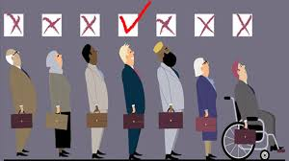

Discrimination also manifests in different ways. The scenarios above are examples of individual discrimination, but other types exist. Institutional discrimination occurs when a societal system has developed with embedded disenfranchisement of a group, such as the U.S. military's historical nonacceptance of minority sexualities (the "don't ask, don't tell" policy reflected this norm). While the form and severity of discrimination vary significantly, they are considered forms of oppression. Institutional discrimination can also include the promotion of a group's status, such in the case of privilege, which is the benefits people receive simply by being part of the dominant group.

* ***EXCLUSION:***

Exclusion is a complex and multifaceted phenomenon that refers to the denial or limitation of people's participation in the economic, social, and cultural life of their society. It is a dynamic process that can be caused by a variety of factors, including poverty, discrimination, and lack of access to education and employment opportunities. Social exclusion can have a profound impact on individuals and communities, leading to social isolation, marginalization, and deprivation.



Exclusive leadership is autocratic in its nature, with the leader taking sole responsibility for decision making. While he or she may invite ideas and discussion, the final say is the word of the leader. In this style of leadership, the leader accepts full responsibility and accountability.

When examining ways to motivate employees in the workplace, exclusive leadership may not spring to mind. However, this style of leadership enables rapid decisions to be taken during periods of chaos or change. This said, autocratic leadership limits employee engagement and individual development during change, potentially increasing resistance to change and inhibiting the progress of a change project.

* **Self-Esteem:**

Self-esteem involves having a positive sense of self-worth and believing in one’s own competence. Leaders with high self-esteem are not narcissistic or over-confident. Instead, they are secure in their strengths while recognizing areas for self-improvement. Rather than shy away from potential failure or rejection, individuals with high self-esteem are willing to take risks and face challenges.



Self-esteem is your overall opinion of yourself, and your beliefs about your abilities and limitations. Self-esteem is shaped by your thoughts, relationships, and experiences, including those related to culture, religion, and societal status. Many beliefs you hold about yourself today reflect messages you've received from others over time. Students in their college years often re-examine their values and develop new or altered perceptions of themselves. **“Self-esteem is literally defined by how much value people place on themselves. It is the evaluative component of self-knowledge. High self-esteem refers to a highly favourable global evaluation of the self. Low self-esteem, by definition, refers to an unfavourable definition of the self. (…)**

**How to Improve Your Self-Perception**

**Be Patient with Yourself:** The most important thing to keep in mind about boosting your self-esteem is that stable, long-term improvements to self-esteem do not happen overnight. It will take time and effort to undo years of conditioned negative thought patterns and replace them with healthier, more positive ones. However, habits that have been learned can also be unlearned. Self-perceptions can be gradually shifted to be more supportive, realistic, and positive.

**Avoid Dwelling on the Negative:** Research suggests that focusing on positive aspects of yourself can improve self-esteem, while dwelling on negative aspects of yourself can worsen it. Negativity is also contagious. Leaders who focus on their failures may indirectly create a pessimistic culture that is overly critical of mistakes, resulting in stress for their direct reports.

**Remember that you don’t have to be perfect:** It is admirable to have high standards, but it is unrealistic and unhealthy to constantly demand perfection of yourself. It is also unreasonable to expect perfection from your co-workers and direct reports. Nobody likes making mistakes or feeling vulnerable. However, if one’s self-esteem is contingent upon external factors, such achieving perfection or being liked and approved of by other people, then it is fragile and easily lost.

**CONCLUSION:**

In summation, the role of leadership and management can work in different capacities, yet be the same when developing an organization. Leadership is nothing if it doesn’t build a systems’-based management structure, and management would have no support without the work of leadership as the backbone of ideals.

To offer parting words after this journey, it is important to understand that whatever leadership or management style chosen, it has to relate to inherent beliefs. Essentially, the iceberg below the surface is not just made in one day, it is shaped and cultivated throughout life through natural and social occurrences, assumptions, and inherent beliefs. It is very important for leaders to find their own icebergs and self-reflect on what their beliefs mean to their leadership styles and how they develop their management strategies. As prospective leaders and managers in society, it is highly important to locate and cultivate a personal leadership style to become successful in a future society.

**REFERENCES:**

1. Parker, S. K. (2013).  Beyond motivation: Job and work design for development, health, ambidexterity, and more.  Annual Review of Psychology, 65, 661-691.
2. Pakarinen, E., Lerkhanen, M-K., Poikkeus, A-M., Sidkkinen, M., & Nuirmi, J-E. (2010). Classroom organization and teacher stress predict learning motivation in kindergarten children.  European Journal of Psychology of Education, 25(3), 281-300. <https://www.jstor.org/stable/23421684>
3. Schermerhorn, J. R., & Wright, B. (2014). Management: Third Canadian Edition. John Wiley & Sons Canada.
4. Fritz, M. S., & Arthur, A. M. (2017). Moderator variables. Oxford Research Encyclopedias, Psychology.